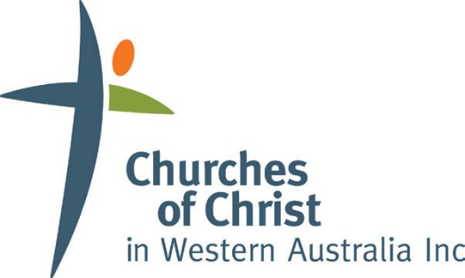

Church Planting Project Application Form

Name of Church ______________________________________________________________

Church Planter ______________________________________________________________

Spouse/Children? ______________________________________________________________

Email _____________________________________ Phone: __________________

Supporting Church ______________________________________________________________
Leader ______________________________________________________________

Email _____________________________________ Phone: __________________

About the Church Planter

How did you come to Christ? Also describe your current walk and ministry practice in prayer.
[Type your answer here…]
Tell us a little about your ministry journey.
[Type your answer here…]
What Church Planting Training have you undertaken?
[Type your answer here…]
Additional Theological Training or plans to study?
[Type your answer here…]

The Church Planter’s Relationship to the Supporting Church

How would you describe the relationship with your supporting Church?
[Type your answer here…]
Do you have any formal agreements in place? If so, please attach.
[Type your answer here…]
Do you currently have a church planting mentor? If so, who?
[Type your answer here…]

Your Relationship with Churches of Christ WA

Are you an accredited minister with COCWA? If so, for how long? Please attach accreditation
[Type your answer here…]
How would you describe your heart for COCWA?
[Type your answer here…]
Are you currently collaborating with other COCWA ministers?
[Type your answer here…]

Vision for the New Church Plant

Statement of your vision for the new church
[Type your answer here…]
Describe in fifty words or less, the ideal picture of what the new church might look like
[Type your answer here…]
Church Planting Model & Philosophy
[Type your answer here…]
Location and your target group
[Type your answer here…]

Launch Team

Do you have a launch team? If so, how many are joining your team?
[Type your answer here…]
Describe the demographic of your launch team?
[Type your answer here…]
Do you have further plans to recruit new launch team members?
[Type your answer here…]

Outreach & Mission

What is your community engagement strategy?
[Type your answer here…]
What is your evangelism strategy?
[Type your answer here…]
Will your church have plans to fulfill her part in the Acts 1:8 mission (include any strategies for the Judean, Samarian, and Ends of the Earth spheres of mission)?
[Type your answer here…]

Discipleship Process & Plan

Your process of discipleship to help a curious seeker become a fully devoted follower of Christ (feel free to attach further plans)
[Type your answer here…]
Describe your leadership development plan (feel free to attach further plans)
[Type your answer here…]

Church Planting Multiplication

Your long-term plan for reproducing new churches
[Type your answer here…]

Timeline and Plan

Describe what stage the Church plant is at?
[Type your answer here…]
What do you envisage will be the next stage of development?
[Type your answer here…]
Do you have written plans and timelines that you can attach?
[Type your answer here…]
Proposed launch date of new Church?
[Type your answer here…]

Financial Plan & Request

Have you drafted a preliminary budget (please attach)?
[Type your answer here…]
Do you or do you envisage having multiple income sources? Please explain
[Type your answer here…]
Are you receiving a salary from the new church plant?
[Type your answer here…]
Do you have ‘tentmaking’ income?
[Type your answer here…]

Declaration
I believe that the details in this application are true and correct to the best of my knowledge. I have attached the necessary items as per the checklist below and agree to supply additional information as requested.
I have read, understood, and wholeheartedly commit to the COCWA Church Planting Design Principles. If this application is successful, I understand that a further partnership agreement will be put into place.

Applicant Name: ____________________________ Date: ___________________

Signature: ____________________________________

Thank you for taking the time to fill in this application. For more info and to submit please contact Daron Crothers churchplanting@cocwa.com.au

CHECKLIST | - Church Planting Agreement with Supporting Church | - Leadership Development Plan | - Written Plans & Timelines
 | - Discipleship Plan | - COCWA Accreditation | - Preliminary Budget

